MACH4METAL

Metalworking machinery
Transito 21,
6909 DA BABBERICH
Netherlands
Tel. +31 (0)316 – 247123
Fax. +31 (0)316 - 247956
info@mach4metal.com
www.mach4metal.com

Account No: 66.52.13.883
IBAN : NL33 INGB 0665 2138 83
BIC : INGBNL2A

CNC Bed milling machine Ki HEUNG
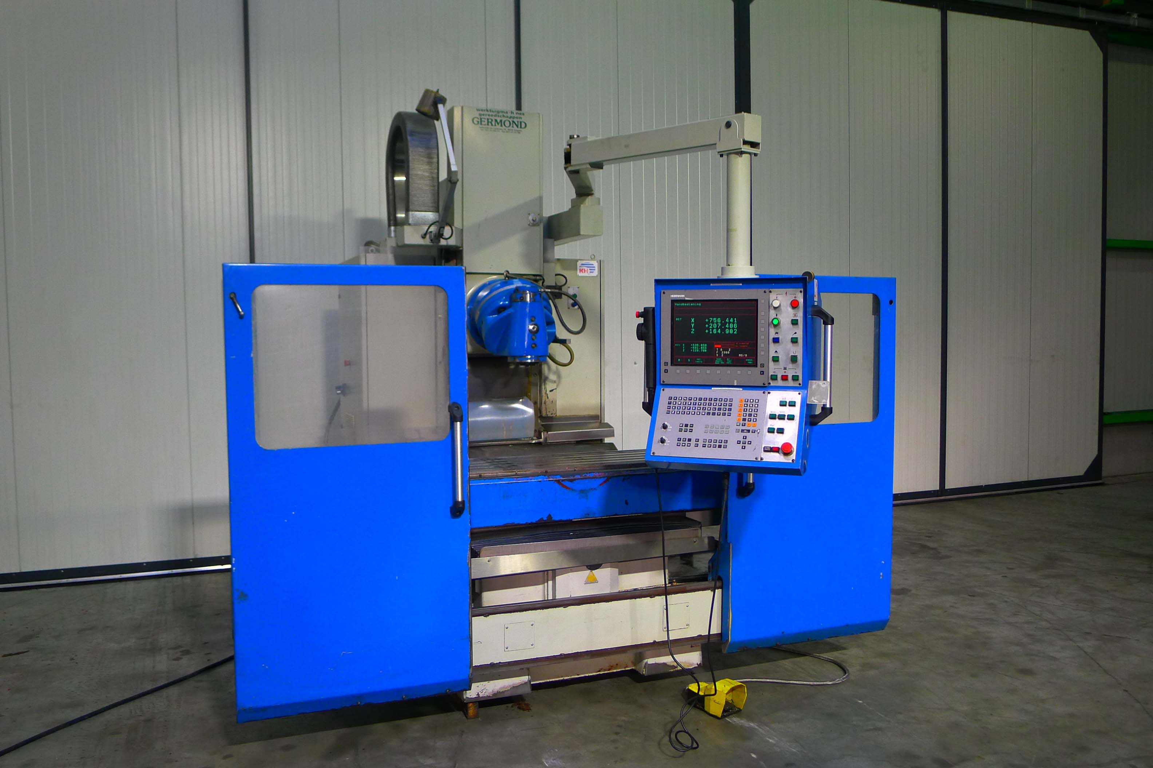
- Make : KIHEUNG Korea
- Typ : Combi U3Z
- Age : 05 . 2000
- No. : 1200 . 599

- Table dimensions
- Length : 1.700
- Width : 470
- Work piece Load : 1.500
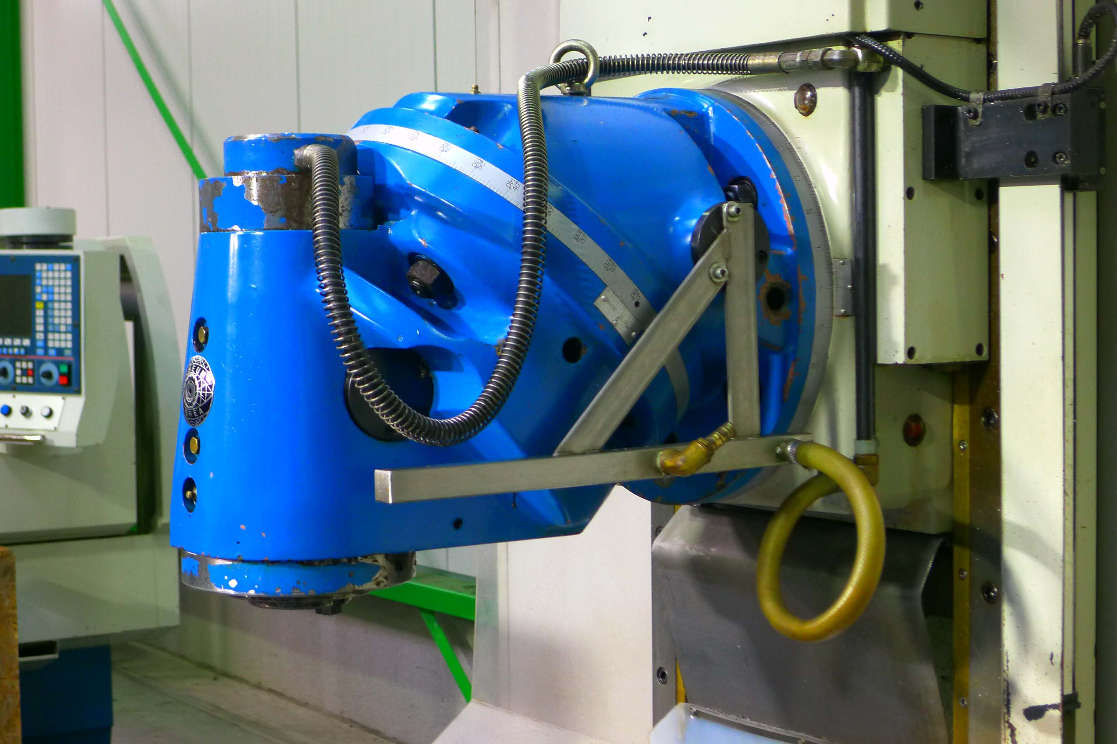
- Movements – Travels
- X : 1.400 / 1.100
- Y : 600
- Z : 590

- Spindle : iso 50
- Speeds : 2.500 Rpm
- Milling head power : 11 kW

- Feeding range : 0.01 – 4.000 rpm
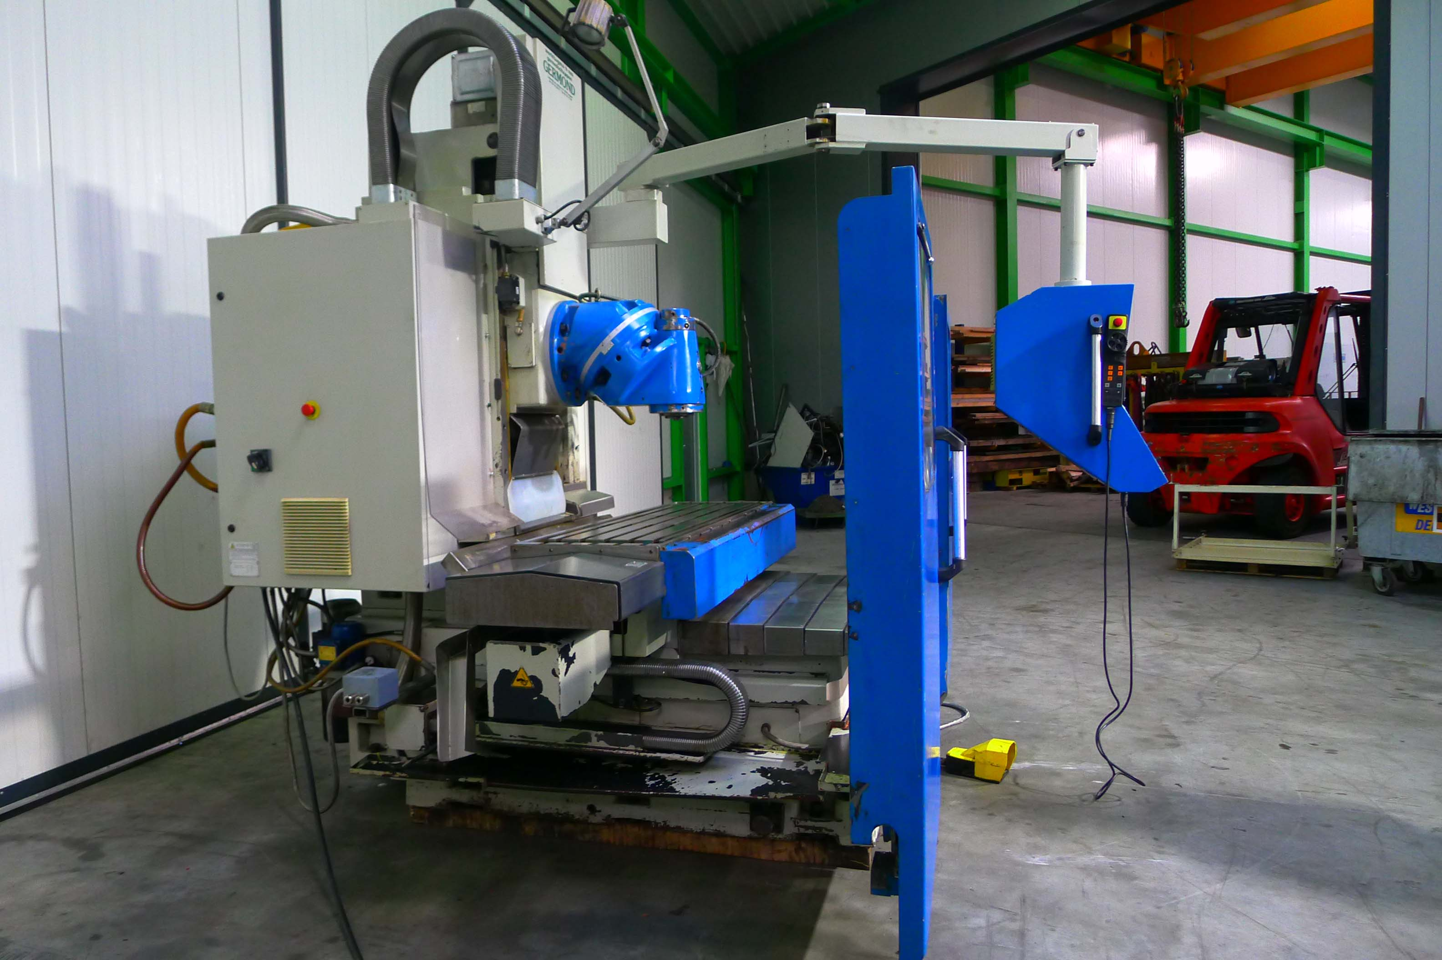
- Rapid traverse : 0.01 – 8.000 rpm

- Universal milling head
- Dr. HeidenHain TNC 426 - 3 axis CNC
- Dr. HeidenHain HR 410 handwheel
- 2 Doors on front side

- In 2011 main drive renewed
- In 2013 new HeidenHain monitor

- Dimensions : 3.960 / 2.950 / 2.700
- Weight : 6.000 Kg

Please Note: The above information has been obtained to the best of our ability and belief from, and from the manufacturers where possible. It is given in good faith, but its accuracy can not be guaranteed. Accordingly, it will not form a representation or constitute contr actual terms. We advise you to check any vital details!

